PUBLICATIONS DATA ANALYSIS

BY KISHORE KUMAR RAVI (DATA ANALYST)

The publication database analysis project delves into the intricate world of publishing, exploring various aspects that contribute to the success and performance of authors, titles, publishers, and stores. Through data-driven insights, I aim to uncover patterns, trends, and relationships within the dataset that shed light on the dynamics of the publishing industry.

OBJECTIVE.

explore how factors such as author demographics, book genres, pricing strategies, payment terms, and store locations influence sales and market presence

ER DIAGRAM :

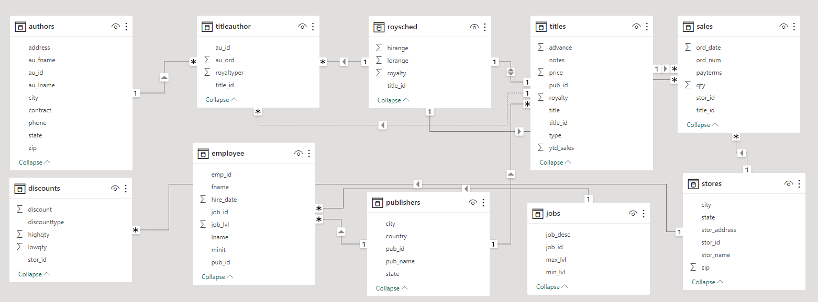

TABLE UNDERSTANDINGS ;

Authors: Represents individual authors who contribute to the books published by the company. Each author is identified by a unique author ID and contains attributes such as author name and contact details.

TitleAuthor: This table establishes a many-to-many relationship between authors and book titles. It serves as a junction table, linking authors to the titles they have written or co-authored. It contains foreign keys for author ID and title ID.

RoySched: Stores information about the royalty payment schedules for authors based on book sales and other factors. It includes attributes like royalty schedule ID, payment terms, and percentage of royalties.

Titles: Contains details about book titles published by the company. Each title is identified by a unique title ID and includes attributes like book title, genre, publication date, and price.

Sales: Records sales transactions for each book title, including the date of sale, quantity sold, and revenue generated. It links to the Titles table using a foreign key for title ID.

Stores: Represents bookstores where the company's titles are available for purchase. Each store is identified by a unique store ID and contains attributes like store location and contact information.

Jobs: Stores employee job details within the publishing company, including job titles, job descriptions, and salaries. Each job is identified by a unique job ID.

Publishers: Holds data about publishers that collaborate with the company for book distribution. Each publisher is identified by a unique publisher ID and contains attributes like publisher name and contact details.

Employee: Represents employees working in the publishing company. Each employee is identified by a unique employee ID and contains attributes like employee name, job title (foreign key to Jobs table), and contact information.

Discounts: Records any special offers or discounts applicable to book sales. It includes attributes like discount type, discount value, and validity period.

POWER BI QUESTIONS

1.What is the distribution of authors by age group or gender?

The available data does not provide enough information to determine the gender and age of the authors mentioned ,as it does not contain the information of age and gender of authors.

2. How does the contract status of authors compare between different regions?

1.opened a matrix in the power bi report view

2.added city in the y-axis and count of contract in the x-axis to get the no. of active contract of authors.

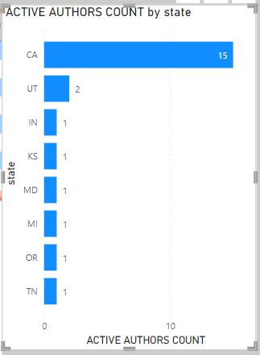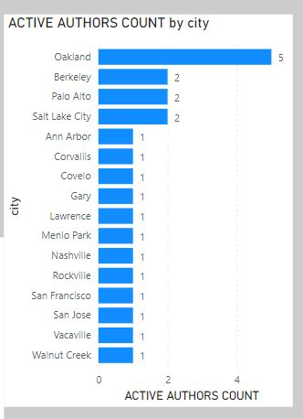

* Contract Status 1: In cities like Oakland, Berkeley, Palo Alto, and Salt Lake City, all authors have a contract status of 1, which means they have a contract with the publisher. These regions have authors who are more likely to have contracts for publishing their works.
* Contract Status 0: In some cities like Lawrence, Nashville, Vacaville, and Oakland, there are authors with a contract status of 0, indicating that they do not have a contract with the publisher. These regions have authors who may have a different publishing arrangement or may not have any contractual agreements.

3.Which authors have published the highest number of titles?

opened a matrix added author name from authors table in y-axis and titles from the title_fact table .

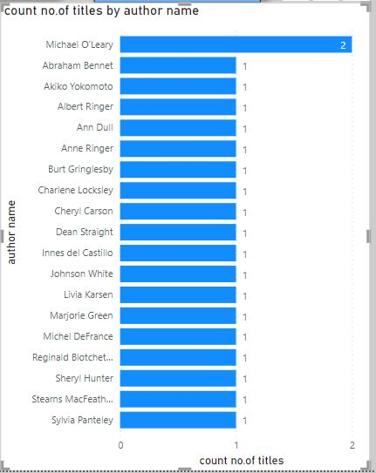

Findings;Michael O'Leary from San Jose City of CA state has published 2 titles, namely,

1.Cooking with Computers: Surreptitious Balance Sheets.

2.Sushi, Anyone?

4 .How many publishers are located in each city or state?

Used sql query to founded the count.

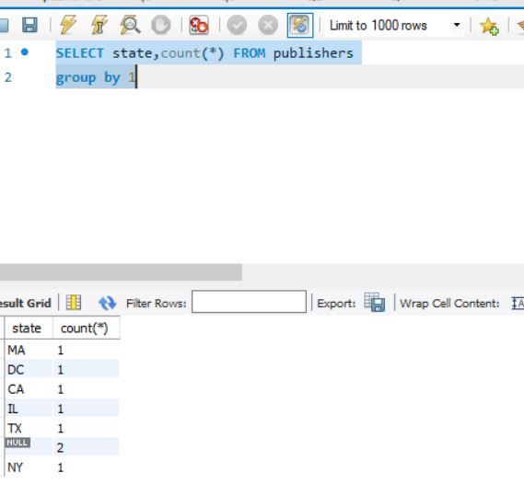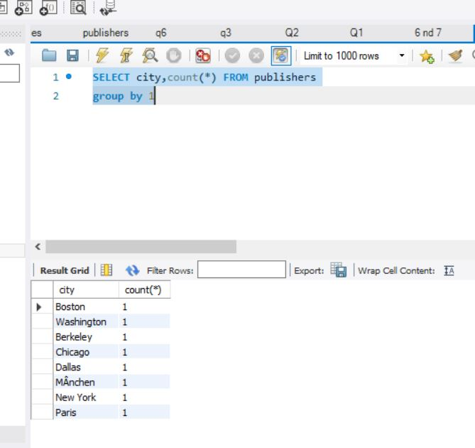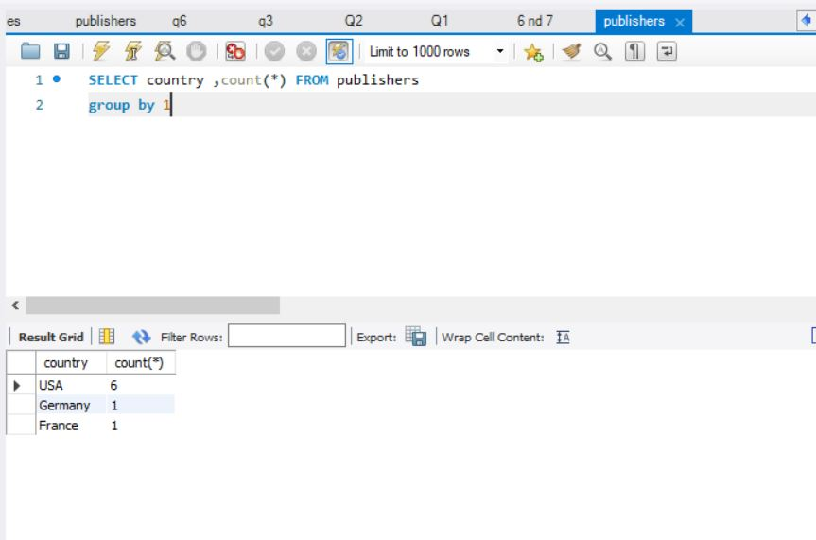

Q5-What are the top publishers in terms of sales revenue?

&

Q6-How does the number of titles published vary among different publishers?

used sql query to found out the top publishers sales and the total title published

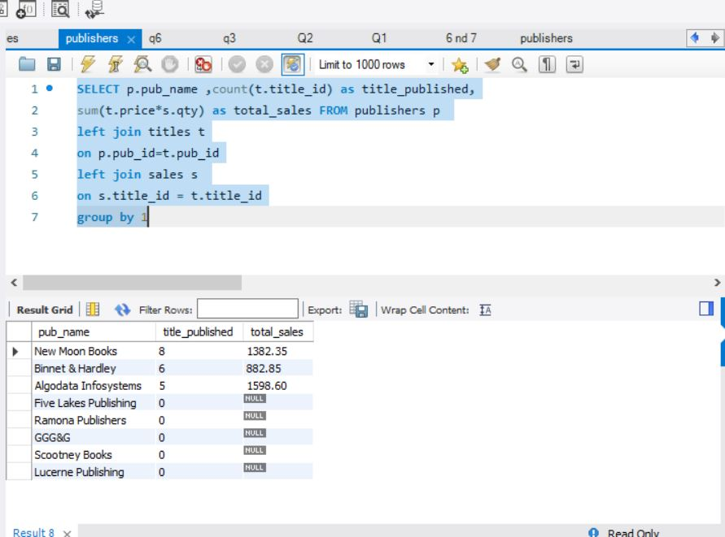

|  |  |  |
| --- | --- | --- |
| PUBLISHERS | Title Published | Total Sales |
| New Moon Books | 8 | 1382.35 |
| Binnet & Hardley | 6 | 882.85 |
| Algodata Infosystems | 5 | 1598.6 |
| Five Lakes Publishing | 0 | NULL |
| Ramona Publishers | 0 | NULL |
| GGG&G | 0 | NULL |
| Scootney Books | 0 | NULL |
| Lucerne Publishing | 0 | NULL |

FINDINGS:

Where Algodata Infosystems publishers from CA state has less titles published in publisher list had more sales of 1598$.

Q7-What is the distribution of book genres in the database?

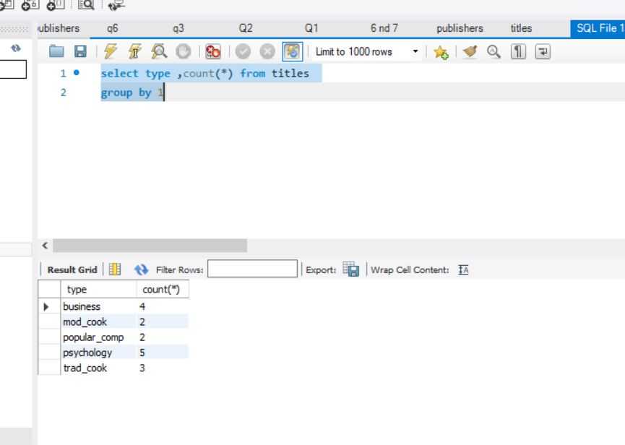

Q8-How have the sales of top-selling titles evolved over time?

Using sql query founded the top selling title and used its sale trend to finds its sales trend.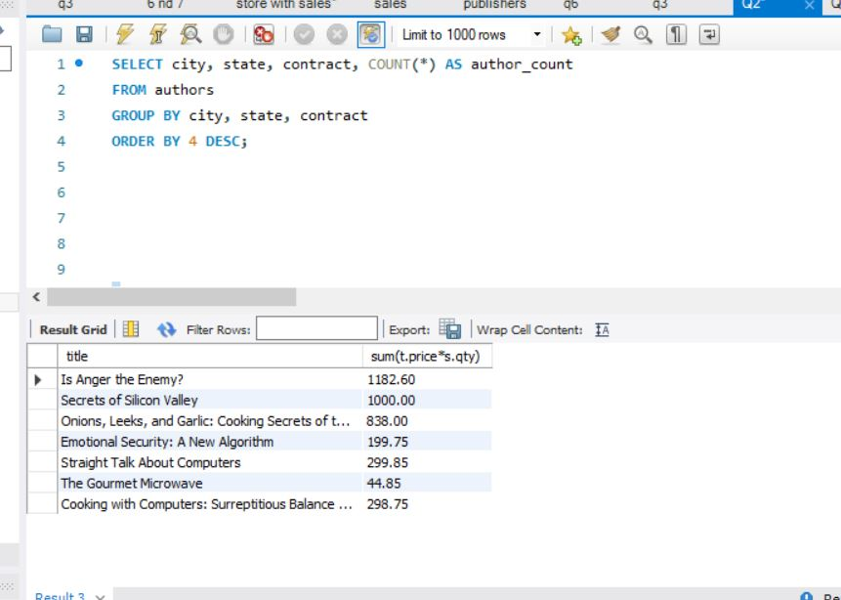

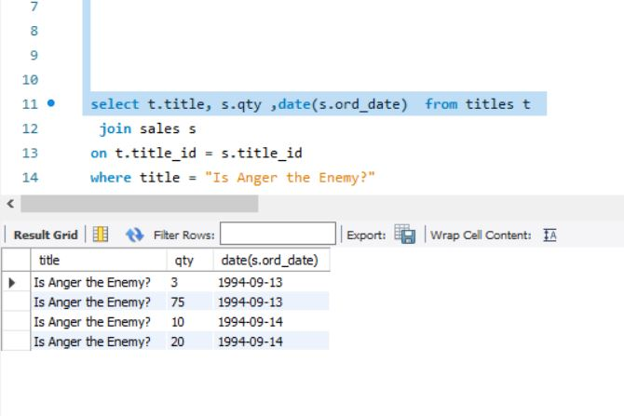

Result :

As we have only 2 days of history for the top sold books , its not sufficient to interpret in it .but when we see for those days it show a downfall.may after the review of the books it may fellen down.

Q9-What is the relationship between book prices and sales performance?

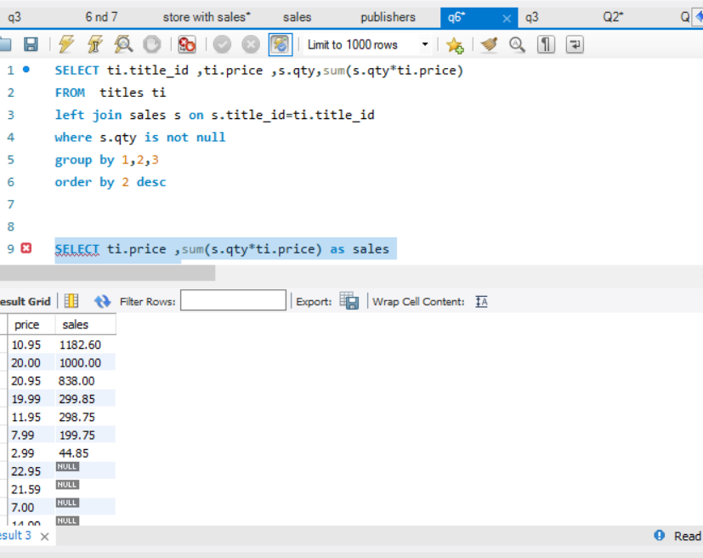

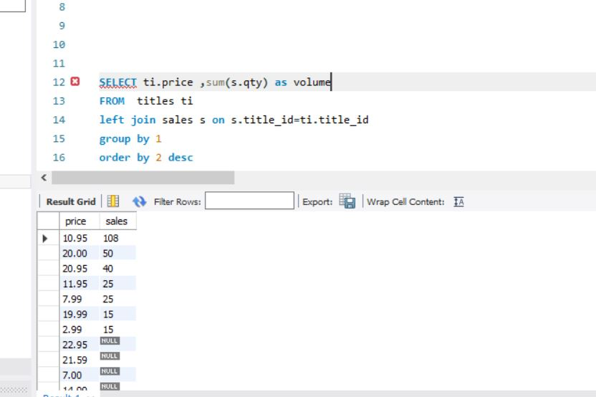

Key findings for price with sales:

1.Books priced at $10.95 generated the highest total sales of $1182.60, indicating that this price point may be attractive to customers and result in higher sales.

2.Books priced at $20.00 achieved a total sales of $1000, which is the second-highest among the price points. This suggests that a higher price point can also lead to significant sales revenue.

3.Books priced at $2.99 and $19.99 had the lowest total sales of $44.85 and $299.85, respectively. It may indicate that lower-priced books may not generate substantial revenue compared to higher-priced books.

4.The pricing at $7.99 resulted in a total sales figure of $199.75, which is in the mid-range. This indicates that books at this price point can still contribute to reasonable sales revenue.

5.There is a variation in the total sales based on different price points, indicating that pricing strategy can significantly impact book sales and overall revenue

Q10-How have book sales varied on a monthly or quarterly basis?

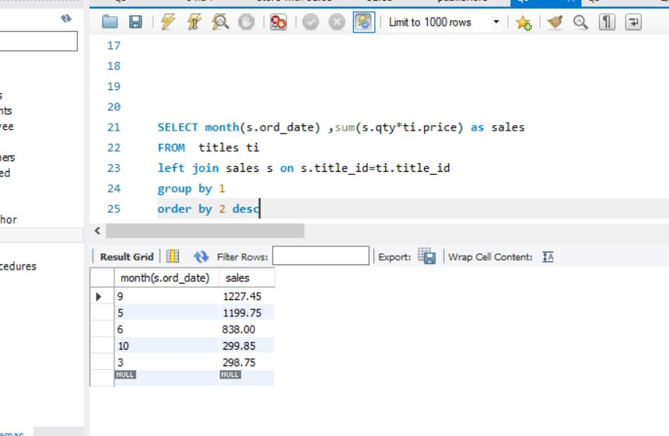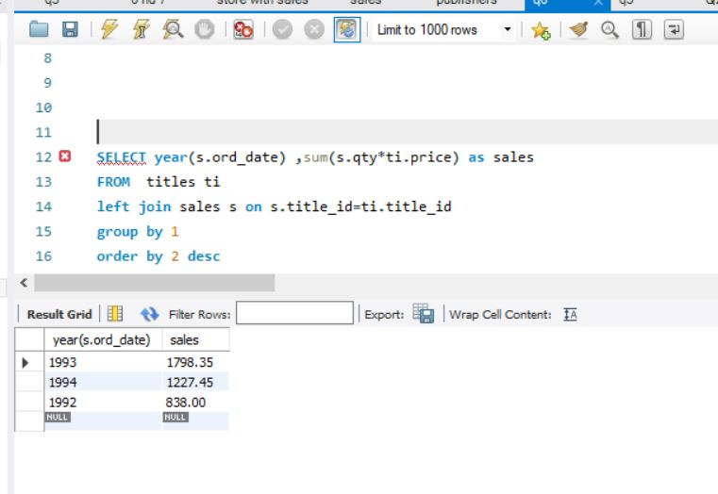

Quarterly Variation:

Q2 1992: 40

Q2 1993: 75

Q3 1994: 120

Monthly Variation:

March 1993: 25

May 1993: 50

June 1992: 40

September1994: 120

Octomber 1993: 15



Q11-Which titles and stores generate the highest sales revenue?

Store :

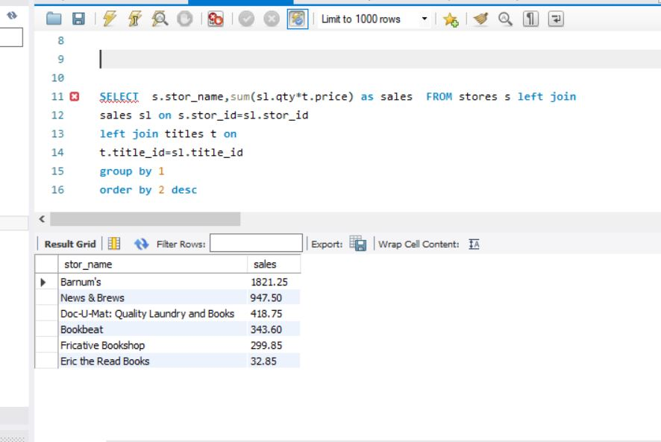

Titles :

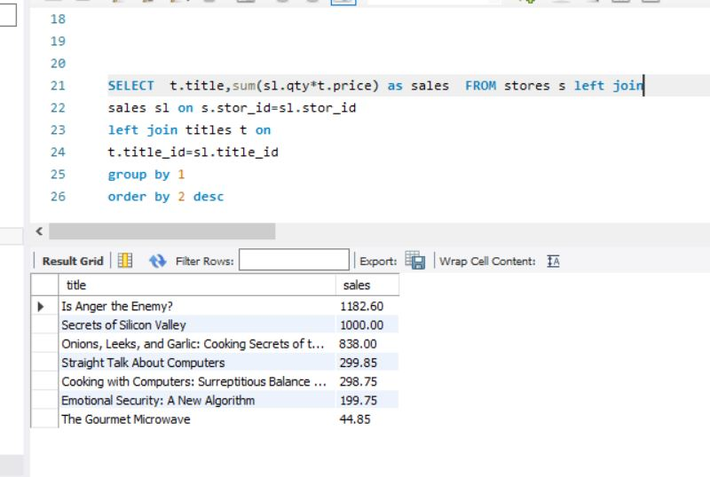

HIGHEST SALES REVENUE

1. TITLE–

IS ANGER THE ENEMY BY ALBERT RINGER (1821.25$)

2.STORE –

BARNUM’S ( 1821.25 $) AND (125 SOLD VOLUME)

Q12-How do different payment terms influence sales volumes?

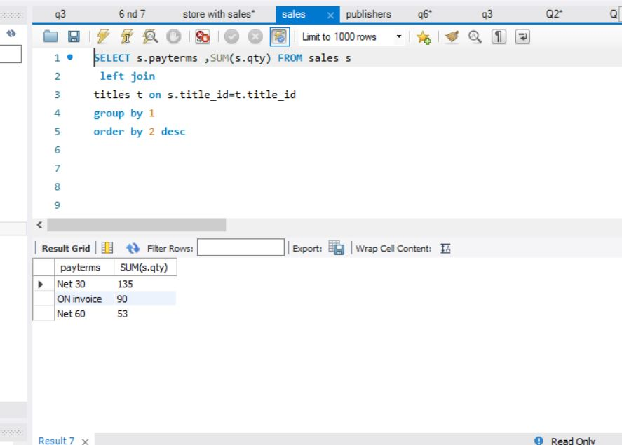

Variation:

1.Net 30: Customers who prefer "Net 30" payment terms may have a tendency to make purchases more frequently and promptly. They are likely to pay for their purchases within 30 days of the invoice date. This could lead to more consistent sales revenue for the seller as payments are received relatively quickly.

2.ON Invoice: Customers who prefer "ON invoice" payment terms pay for their purchases immediately upon receipt of the invoice. This payment preference could indicate that these customers prioritize timely payments and may be more financially stable. It can lead to improved cash flow for the seller as payments are received upfront.

3.Net 60: Customers who prefer "Net 60" payment terms may require a longer time to pay for their purchases, up to 60 days after the invoice date. This could suggest that these customers prioritize cash flow management and may have stricter budgetary constraints. Sellers offering Net 60 terms may attract customers who appreciate flexibility in payment timelines.

13. What is the performance ranking of stores based on sales revenue?



|  |  |  |
| --- | --- | --- |
| RANK | STORE NAME | TOTAL SALES |
| 1 | Barnum's | 1821.25 |
| 2 | News & Brews | 947.5 |
| 3 | Doc-U-Mat: Quality Laundry and Books | 418.75 |
| 4 | Bookbeat | 343.6 |
| 5 | Fricative Bookshop | 299.85 |
| 6 | Eric the Read Books | 32.85 |

Q14-How are stores geographically  
 distributed?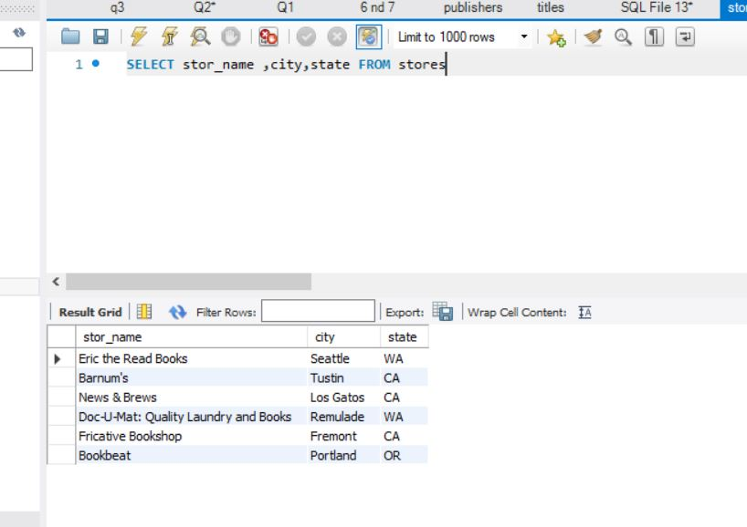

1.Eric the Read Books is located in Seattle, WA.

2.Barnum's is located in Tustin, CA.

3.News & Brews is located in Los Gatos, CA.

4.Doc-U-Mat: Quality Laundry and Books is located in Remulade, WA.

5.Fricative Bookshop is located in Fremont, CA.

6.Bookbeat is located in Portland, OR.

The stores are spread across multiple cities and states, indicating a diverse geographical distribution for their market coverage.

15-What is the impact of discounts on sales volumes for different stores?

"The data provided earlier does not establish any relationship between discounts and sales, making it insufficient to answer the questions related to how discounts impact sales volumes for different stores and any insights derived from the popularity of different book genres in relation to sales figures."

EDA QUESTIONS

1.How does the demographic profile of authors relate to their publishing success?

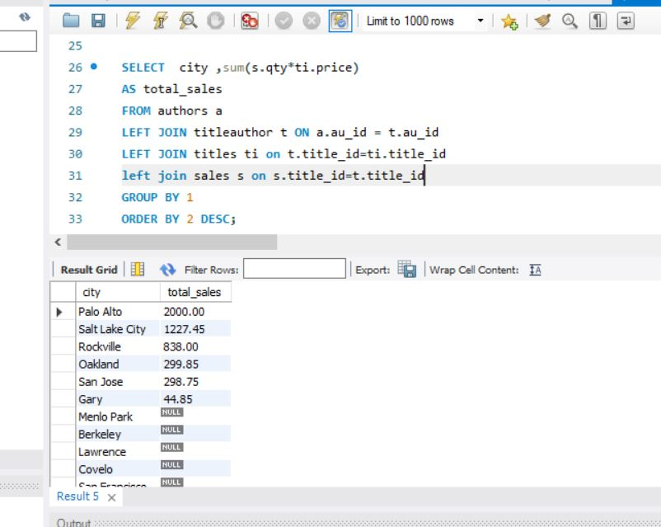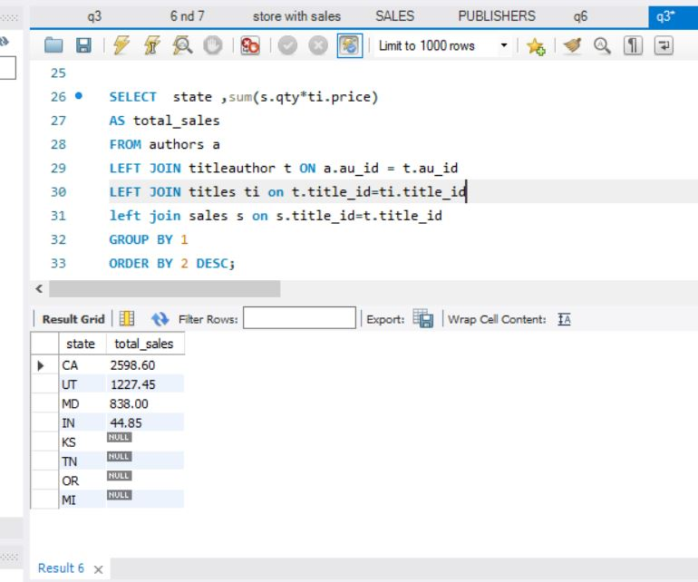

Based on the provided data, we can analyze how the publishing output of authors varies based on their demographic characteristics, such as city, state, and contract status.

City and State Analysis:

1.Salt Lake City, UT: Albert Ringer and Anne Ringer have published 4 and 1 title(s), respectively.

2.San Jose, CA: Michael O'Leary has published 2 titles.

3.Menlo Park, CA: Johnson White has published 1 title.

4.Oakland, CA: Marjorie Green, Dean Straight, Abraham Bennet, Stearns MacFeather, and Livia Karsen have each published 1 title.

5.Berkeley, CA: Cheryl Carson and Ann Dull have each published 1 title.

6.Covelo, CA: Burt Gringlesby has published 1 title.

7.San Francisco, CA: Charlene Locksley has published 1 title.

8.Corvallis, OR: Reginald Blotchet-Halls has published 1 title.

9.Walnut Creek, CA: Akiko Yokomoto has published 1 title.

10.Ann Arbor, MI: Innes del Castillo has published 1 title.

11.Gary, IN: Michel DeFrance has published 1 title.

12.Rockville, MD: Sylvia Panteley has published 1 title.

13.Vacaville, CA: Heather McBadden has not published any titles.

14.Lawrence, KS: Meander Smith has not published any titles.

15.Nashville, TN: Morningstar Greene has not published any titles.

Contract Status Analysis:

Authors with Contract (1): Albert Ringer, Michael O'Leary, Johnson White, Marjorie Green, Cheryl Carson, Dean Straight, Abraham Bennet, Ann Dull, Burt Gringlesby, Charlene Locksley, Reginald Blotchet-Halls, Akiko Yokomoto, Innes del Castillo, Michel DeFrance, Stearns MacFeather, Livia Karsen, Sylvia Panteley, Sheryl Hunter, and Anne Ringer.

Authors without Contract (0): Meander Smith, Morningstar Greene, Dirk Stringer, and Heather McBadden.

From this analysis, we can observe that the publishing output of authors varies based on their demographic characteristics. Certain cities and states have more prolific authors, while others have authors with fewer or no published titles. Additionally, authors with a contract tend to have a higher publishing output compared to authors without a contract. However, further analysis would be needed to understand the exact relationship between demographic characteristics and publishing success.

FINDINGS:

* Location Impact: Authors from certain cities and states have higher publishing success compared to others. For example, authors from Salt Lake City, UT, and San Jose, CA, have published multiple titles and achieved higher total sales.
* Total Sales Variation: There is a variation in total sales within authors from the same city or state. For example, Michael O'Leary and Dean Straight, both from Oakland, CA, have published one title each, but their total sales differ significantly (298.75 and 299.85, respectively).
* High Sales in Specific Regions: Authors from Palo Alto, CA, and Salt Lake City, UT, have achieved high total sales of 1000, which could indicate a potential market demand in these regions.
* Number of Titles Published: In states, CA has published a total of 14 titles whereas in KS and TN no titles have been published, where other states are equally distributed with 1title. In cities, OAKLAND remains highest with 4 titles.

2. What patterns or trends can be observed in the contract status of authors across different regions?

Contract Status 1: In cities like Oakland, Berkeley, Palo Alto, and Salt Lake City, all authors have a contract status of 1, which means they have a contract with the publisher. These regions have authors who are more likely to have contracts for publishing their works.

Contract Status 0: In some cities like Lawrence, Nashville, Vacaville, and Oakland, there are authors with a contract status of 0, indicating that they do not have a contract with the publisher. These regions have authors who may have a different publishing arrangement or may not have any contractual agreements.

FINDINGS:

1.Limited Sample Size: In several cities and states, there is only one author listed, making it difficult to draw meaningful conclusions about contract status trends in these regions.

2.Contract Status 1 Dominance: Across various cities, authors with a contract status of 1 seem to be more prevalent compared to authors with a contract status of 0, suggesting that most authors have contracts with the publisher.

Overall, the data indicates that most authors from the listed cities have contracts with the publisher, and only a few have a contract status of 0. However, further analysis with a larger and more diverse dataset would be needed to draw more robust conclusions about contract status trends across different regions.

3. How does the publishing output of authors vary based on their demographic characteristics?

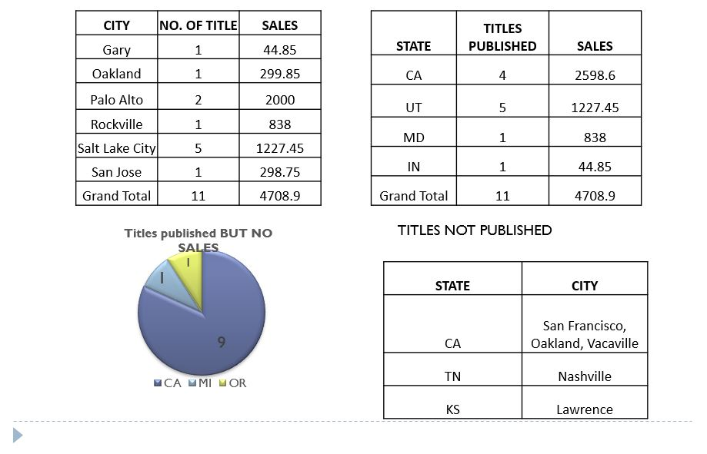

1.Authors based in Salt Lake City, UT, and San Jose, CA, have shown higher publishing output with multiple titles published and relatively higher total sales compared to authors in other cities and states.

2.Among the authors analyzed, those with a contract tend to have a higher number of titles published compared to authors without a contract. However, the sales performance varies across both contract and non-contract authors, with some authors achieving notable total sales despite having a single published title.

3.The geographical location seems to have an impact on publishing success, with certain cities, such as Palo Alto, CA, having authors with impressive sales revenue, while other cities like Vacaville, CA, have authors with no sales data available, indicating varying publishing opportunities across regions.

FINDINGS

1.from the table indicate that the authors MeanderSmith, CharleneLocksley, MorningstarGreene, DirkStringer, and HeatherMcBadden have not published any titles. This suggests that these authors have not been actively involved in publishing books based on the provided data.

2.there have been no titles published and no corresponding sales recorded for authors located in the cities of Lawrence, KS; San Francisco, CA; Nashville, TN; Oakland, CA; and Vacaville, CA. This indicates that there is no publishing activity or sales associated with authors from these specific cities and states based on the provided information.

3.The data reveals that the authors listed, including Johnson White, Marjorie Green, Cheryl Carson, Michael O'Leary, Abraham Bennet, Burt Gringlesby, Reginald Blotchet-Halls, Akiko Yokomoto, Innes del Castillo, Stearns MacFeather, and Livia Karsen, have published titles but have not recorded any sales. This suggests that although these authors have produced books, they have not generated any sales revenue based on the provided information.

4. How does the geographic distribution of publishers correlate with their sales performance?

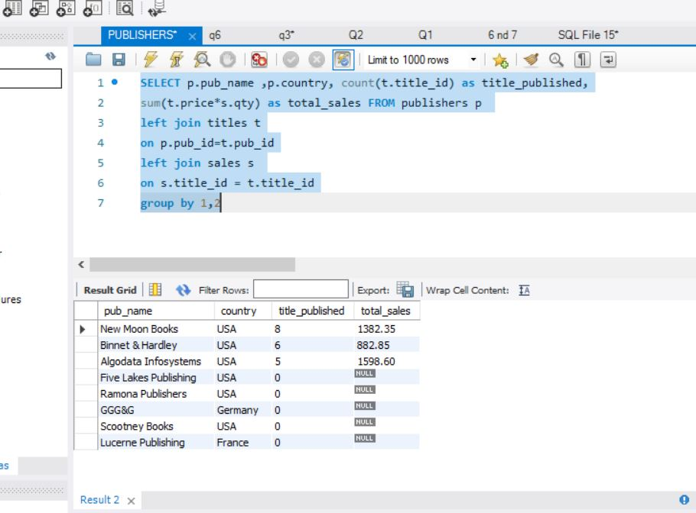

1.High Sales Performance in Specific Cities and States: Publishers "New Moon Books" in Boston, "Binnet & Hardley" in Washington, and "Algodata Infosystems" in Berkeley, all located in different cities and states within the USA, have reported significant total sales. This suggests that these particular cities and states are performing well in terms of book sales.

2.Publishers with Missing Sales Data: Some publishers, like "Five Lakes Publishing" in Chicago and "Ramona Publishers" in Dallas, both located in different states in the USA, have "NO SALES" listed. The absence of sales data for these publishers makes it challenging to assess their sales performance or correlate it with their geographic location.

3.International Publishers with No Sales Data: International publishers such as "GGG&G" in MÃ‚Anchen, Germany, and "Lucerne Publishing" in Paris, France, also have "NO SALES" listed. Without sales data, we cannot determine how their sales performance correlates with their geographic locations.

5. What strategies can be identified from successful publishers in driving sales revenue?

From the provided data, we don't have specific information on the strategies employed by successful publishers to drive sales revenue. However, we can hypothesize some strategies that successful publishers often use to boost sales revenue based on industry best practices and common approaches:

1.Diversified Catalog: Successful publishers often have a diverse catalog with a wide range of titles and genres that appeal to various audiences. This strategy allows them to target different segments of the market and attract a broader customer base.

2.Strong Marketing and Promotion: Effective marketing and promotional activities play a crucial role in driving sales. Successful publishers invest in advertising, social media marketing, email campaigns, and partnerships to create awareness and generate interest in their books.

3.Building Author Relationships: Publishers that maintain strong relationships with their authors tend to benefit from repeat publications and loyal readership. Working closely with authors can lead to quality content and better market positioning.

4.Distribution Channels: Utilizing multiple distribution channels, including both traditional bookstores and online platforms, can increase a publisher's reach and accessibility, leading to higher sales.

5.Pricing and Discount Strategies: Careful pricing and discount strategies can attract price-sensitive customers and encourage bulk purchases, contributing to increased sales.

6.High-Quality Editing and Design: Publishers that prioritize high-quality editing, formatting, and cover design enhance the perceived value of their books, attracting more readers and potentially increasing sales.

7.Market Research and Trend Analysis: Successful publishers stay up-to-date with market trends, conduct market research, and analyze reader preferences to identify potential bestsellers and make data-driven decisions.

8.Book Series and Sequels: Publishers often release book series or sequels to successful titles, leveraging the popularity of existing works to generate anticipation and drive sales for new releases.

9.Customer Engagement: Engaging with readers through book signings, author events, and online communities can create a loyal fan base, leading to word-of-mouth recommendations and increased sales.

10.Partnerships and Collaborations: Collaborating with other publishers, authors, or media outlets can expand a publisher's audience and create cross-promotional opportunities, which can positively impact sales.

FINDINGS:

It is essential to note that each successful publisher may employ a unique combination of these strategies, and the effectiveness of each strategy may vary based on the target audience, genre, and other market factors. Additionally, the success of a publishing strategy often relies on continuous adaptation to changing market conditions and trends.

6. How does the number of titles published by a publisher impact their overall market presence and success?

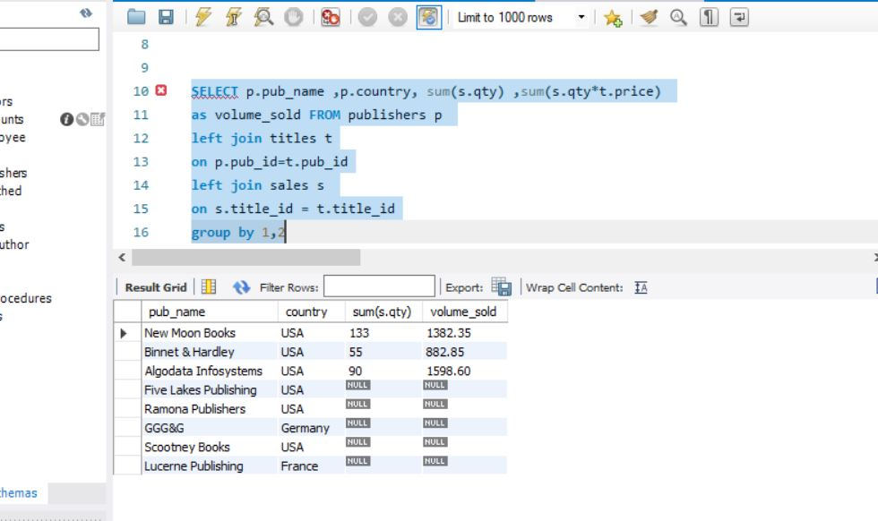

we can observe the number of titles published by each publisher and their corresponding sales performance:

1.New Moon Books (USA): 133 books sold

2.Algodata Infosystems (USA): 90 books sold

3.Binnet & Hardley (USA): 55 books sold

4.Five Lakes Publishing (USA): 0 books sold

5.Ramona Publishers (USA): 0 books sold

6.GGG&G (Germany): 0 books sold

7.Scootney Books (USA): 0 books sold

8.Lucerne Publishing (France): 0 books sold

Based on this data, we can observe the following trends:

1.New Moon Books, with 133 books sold, has the highest market presence and success among the listed publishers. Having a substantial number of titles published may have contributed to their higher sales performance.

2.Algodata Infosystems follows with 90 books sold, which suggests that their number of titles published has also positively impacted their market presence and sales success.

3.Binnet & Hardley, with 55 books sold, indicates that the number of titles they publish has contributed to a moderate level of market presence and success.

The remaining publishers (Five Lakes Publishing, Ramona Publishers, GGG&G, Scootney Books, and Lucerne Publishing) have not recorded any sales, indicating that their current number of titles published has not resulted in notable market presence or success in terms of sales.

FINDINGS:

It is important to note that this is a limited dataset, and a more comprehensive analysis would require additional data and considerations such as the quality of the titles, marketing efforts, distribution channels, and competition within the publishing industry. Nonetheless, the data does provide some insights into how the number of titles published can impact a publisher's market presence and sales performance.

7. What insights can be derived from the popularity of different book genres in relation to sales figures?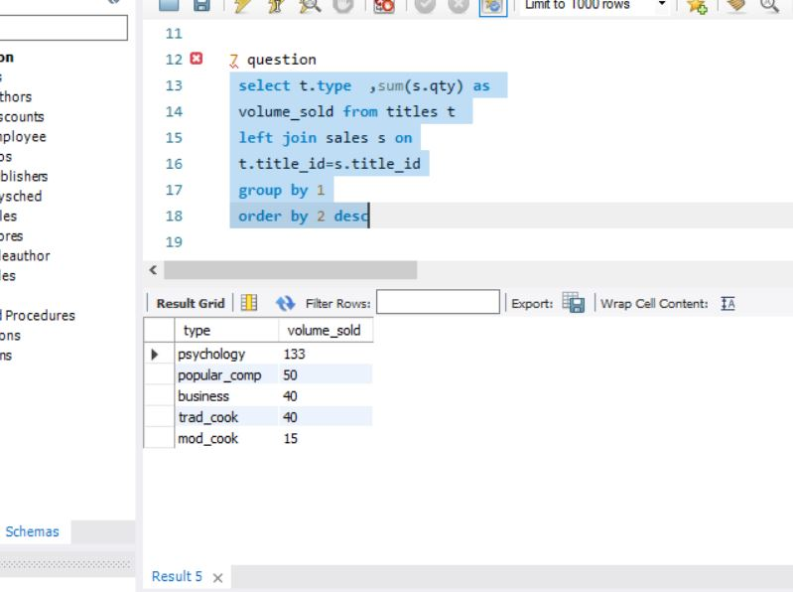

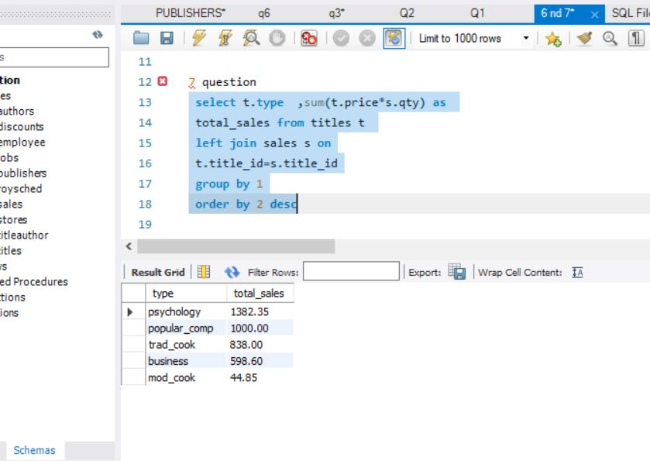

book genres and their corresponding sales figures, we can derive the following insights:

1.Psychology books have the highest sales figures, generating a total revenue of $1382.35. This indicates that there is a significant demand for books related to psychology, and they have been successful in attracting readers and generating sales.

2.Popular computer (popular_comp) books come in second place with total sales of $1000. This suggests that books related to popular computer topics are also well-received by readers and have a strong market presence.

3.Traditional cooking (trad_cook) books have generated sales of $838. This indicates that books on traditional cooking techniques or recipes have found an audience and are contributing to the overall revenue.

Business books have generated total sales of $598.6, which shows that books related to business topics are also contributing to the overall sales figures, although they are not as popular as psychology and popular computer books.

4.The genre of modern cooking (mod_cook) books has the lowest sales figures at $44.85. This suggests that books on modern cooking techniques or recipes may have a smaller audience or face higher competition in the market.

FINDINGS:

The sales data reveals that the "Psychology" genre not only has the highest volume sold (133) but also leads in total sales with $1382.35, indicating strong popularity and revenue generation.

"Popular Computer Science" follows with a volume sold of 50 and total sales of $1000, contributing to a significant market presence.

"Business" and "Traditional Cooking" have similar volume sold (40) but vary in total sales, with "Business" generating $598.6 and "Traditional Cooking" contributing $838.

"Modern Cooking" lags behind with a volume sold of 15 and total sales of $44.85, suggesting lower market demand compared to other genres.

8. How do sales trends of top-selling titles align with broader market dynamics?



TITLE PERFORMANCE:

1. The sales of "Is Anger the Enemy?" and "Onions, Leeks, and Garlic: Cooking Secrets of the Mediterranean" are notably higher than other titles.
2. The data is insufficient as it shows a rapid downfall within a day for the top-selling book in the market. Having only two dates suggests that the reviews of the book may not be good, resulting in a decline in sales.

"Is Anger the Enemy? By ALBERT RINGER - top-selling book

9. How does the pricing strategy impact the sales performance of different titles within the database?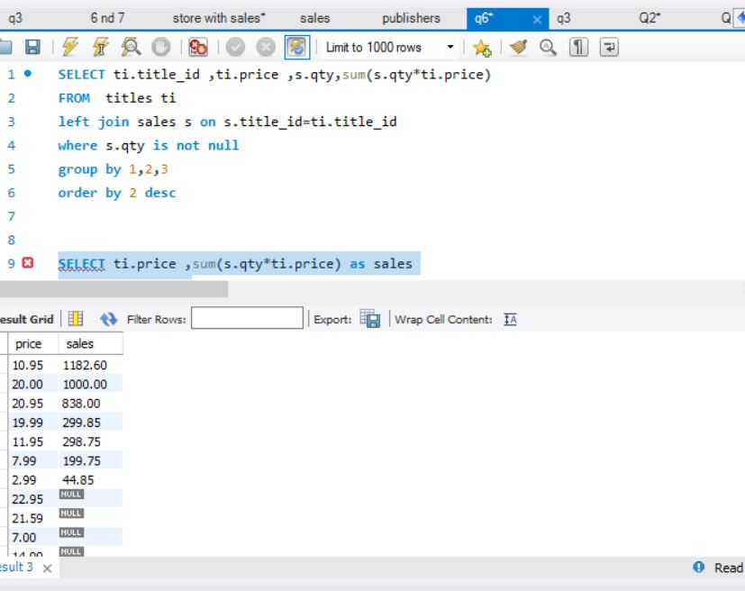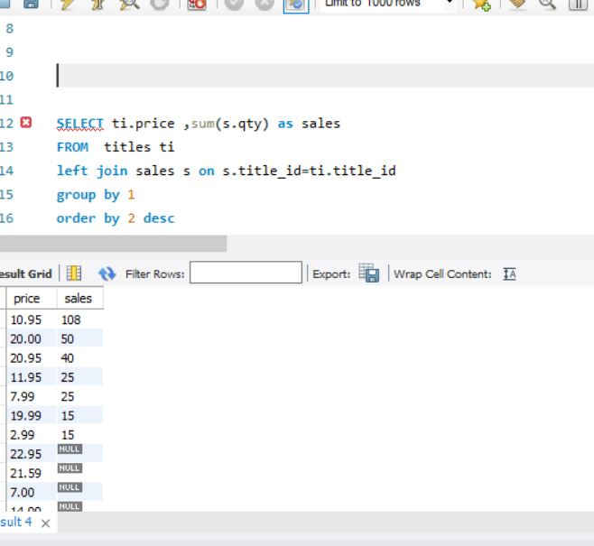

1.The pricing strategy significantly influences the sales performance of different titles in the database. Titles priced at $2.99 and $7.99 have relatively low prices but their sales performance is limited, generating $44.85 and $199.75 respectively.

2. On the other hand, titles priced at $10.95 and $11.95 exhibit strong sales performance, with higher prices correlating with higher sales ($1182.6 and $298.75 respectively).

3.The highest priced title at $20.00 achieves notable sales of $1000, indicating that a premium pricing strategy can result in substantial revenue. However, titles priced at $20.95 and $19.99 also show strong sales, suggesting that a range of pricing points can attract different segments of customers.

4.titles with missing prices ($22.95, $21.59, $7) and sales data also show no significant sales, emphasizing the importance of clear pricing information for potential buyers

5. Overall, an effective pricing strategy should balance price point with perceived value to optimize sales performance.

10. What patterns or seasonality can be observed in the sales trends of books over time?

Key Findings:

1. There is a positive trend in book sales from 1992 to 1994, indicating growth in the demand for books.
2. The months of May and September seem to be the peak seasons for book sales, suggesting that there might be certain factors or events during these months that drive higher sales.

11. What factors contribute to the success of specific titles and stores in generating high sales revenue?

1. Product Selection: Stores with a diverse and well-curated selection of titles tend to attract more customers and generate higher sales.

2. Customer Loyalty: Stores that have built a loyal customer base through excellent customer service.

3. Location: The location of the store plays a crucial role in generating sales revenue.

4. Pricing Strategy: A competitive and well-balanced pricing strategy can influence sales.

5. Marketing and Promotion: Effective marketing strategies, including promotions, discounts, and advertising, can drive customer interest and lead to increased sales.

6. The store with the highest sales is Barnum's (1821.25)

12. How do customer preferences for specific payment terms affect their purchasing behavior and sales outcomes?

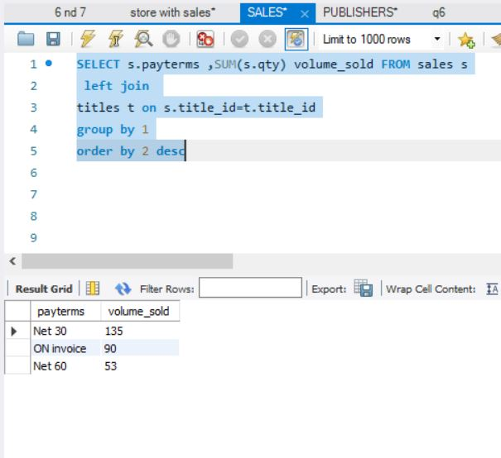

Variation:

1.Net 30: Customers who prefer "Net 30" payment terms may have a tendency to make purchases more frequently and promptly. They are likely to pay for their purchases within 30 days of the invoice date. This could lead to more consistent sales revenue for the seller as payments are received relatively quickly.

2.ON Invoice: Customers who prefer "ON invoice" payment terms pay for their purchases immediately upon receipt of the invoice. This payment preference could indicate that these customers prioritize timely payments and may be more financially stable. It can lead to improved cash flow for the seller as payments are received upfront.

3.Net 60: Customers who prefer "Net 60" payment terms may require a longer time to pay for their purchases, up to 60 days after the invoice date. This could suggest that these customers prioritize cash flow management and may have stricter budgetary constraints. Sellers offering Net 60 terms may attract customers who appreciate flexibility in payment timelines.

* FINDINGS - Payment terms "Net 30" resulted in the highest total sales, followed by "ON invoice" and "Net 60." Customers' payment preferences seem to influence their purchasing behavior, affecting overall sales outcomes.

13. What are the key factors that contribute to the success of high-performing stores in generating sales revenue?

We can assume the key factors that contribute to the success of high-performing stores in generating sales revenue as data is less we can include factors like:

1.Location: High-performing stores are strategically located in areas with high foot traffic, visibility, and accessibility, which attract more customers and drive sales.

2.Product Assortment: Successful stores offer a diverse and attractive range of products that cater to their target market's preferences and demands, increasing the likelihood of making sales.

3.Customer Experience: Providing exceptional customer service, a pleasant shopping environment, and personalized assistance creates a positive experience for customers, leading to repeat business and word-of-mouth referrals.

4.Marketing and Promotion: Effective marketing strategies, advertising, and promotional activities help create awareness, attract potential customers, and drive sales.

5.Pricing Strategy: High-performing stores employ competitive pricing strategies, offering value to customers while ensuring profitability for the business.

6.Inventory Management: Efficient inventory management ensures that popular items are in stock, minimizing stockouts and lost sales opportunities.

7.Staff Training: Well-trained and knowledgeable staff can provide product information, recommendations, and assistance, which enhances the overall customer experience and boosts sales.

8.Customer Loyalty Programs: Implementing loyalty programs or rewards for repeat customers encourages customer retention and increases the likelihood of higher sales from loyal patrons.

9.Online Presence: Establishing an online presence, such as an e-commerce website or social media presence, allows stores to reach a broader audience and drive online sales.

10.Collaboration and Partnerships: Partnering with authors, publishers, or other businesses can lead to exclusive offerings, special events, and cross-promotions, attracting more customers and driving sales.

11.Seasonal and Trend Awareness: High-performing stores stay informed about market trends, seasonal demands, and customer preferences, allowing them to stock relevant products and capitalize on peak sales opportunities.

12.Operational Efficiency: Efficient store operations, streamlined checkout processes, and order fulfillment contribute to a positive customer experience and reduce the chances of cart abandonment.

By effectively leveraging these key factors, high-performing stores can optimize their sales revenue and maintain a competitive advantage in the market.

14. How can store locations be strategically optimized to maximize market coverage and sales potential?

Optimizing store locations strategically to maximize market coverage and sales potential involves a careful analysis of various factors. Here are some key strategies to consider:

1.Market Research: Conduct thorough market research to identify areas with high population density, target demographics, and potential customer demand for your products.

2.Competitor Analysis: Evaluate the locations of competitors and identify gaps in the market where your store can provide unique offerings or better accessibility.

3.Demographic Analysis: Understand the demographics of the target market in each potential location, including age, income levels, interests, and preferences.

4.Foot Traffic and Visibility: Choose locations with high foot traffic, good visibility, and easy accessibility to attract more potential customers.

5.Proximity to Target Customers: Ensure that the store is located close to your target customers' homes, workplaces, or other frequented areas to increase convenience.

6.Infrastructure and Amenities: Consider the availability of parking, public transportation, and other amenities that can enhance the convenience of visiting your store.

7.Growth Potential: Look for locations in areas with ongoing development and growth, as these areas may offer increasing customer demand over time.

8.Cost-Benefit Analysis: Assess the costs associated with each potential location, including rent, utilities, and other expenses, and weigh them against the expected sales potential.

9.Online Presence: Complement physical store locations with an online presence to expand market coverage and reach customers who prefer online shopping.

10.Test Locations: Consider piloting or testing store locations in select areas before making larger investments to assess their performance and viability.

11.Collaboration with Landlords: Negotiate lease terms with landlords to secure favorable conditions and flexibility, especially during the initial stages of the store's operation.

12.Expansion Strategy: Develop a clear expansion strategy that aligns with your business goals and budget, and prioritize locations based on their potential contribution to the overall sales revenue.

By carefully considering these strategies and using data-driven insights, retailers can strategically optimize their store locations to maximize market coverage and tap into their full sales potential. Regularly evaluating the performance of each store location and making necessary adjustments will further enhance the overall success of the retail business

Q15-How do different discount strategies impact customer behavior and sales outcomes for stores?

* The data provided earlier does not establish any relationship between discounts and sales, making it insufficient to answer the questions related to how discounts impact sales volumes for different stores and any insights derived from the popularity of different book genres in relation to sales figures."

*BY KISHORE KUMAR RAVI (DATA ANALYST)*